Girl Scouts of Connecticut
2023-2024 Troop Cookie Volunteer eBudde Instructions
Submitting Final Cookie Rewards

Once all the cookies assigned to your troop have been allocated to the girls it is important to review and submit the troop’s final rewards.
Some of the reward levels offer more than one choice. If you have any girls that have reached these levels you will need to know which reward they have chosen.
The Rewards tab is where the troop will:
- Any sizes needed for girls that earned the t-shirt and/or sweatshirt
- Make reward selections for those levels where the girl gets a choice between two or more rewards
- Submit the rewards for the troop

Troops may only submit the Final Rewards Order once. This is done after you have finalized all orders on the Girl Orders tab. The deadline for submitting Final Rewards is April 26, 2024.
NOTE: If your troop is selecting additional proceeds in lieu of girl rewards (Junior level and older), make sure the Opt out of rewards for additional proceeds box is checked under the Settings tab before you finalize any girl rewards on the Rewards tab.

To finalize individual girl reward selections:
- Click on the Rewards tab from the troop dashboard.
- Click Final Rewards Orders—Fill Out
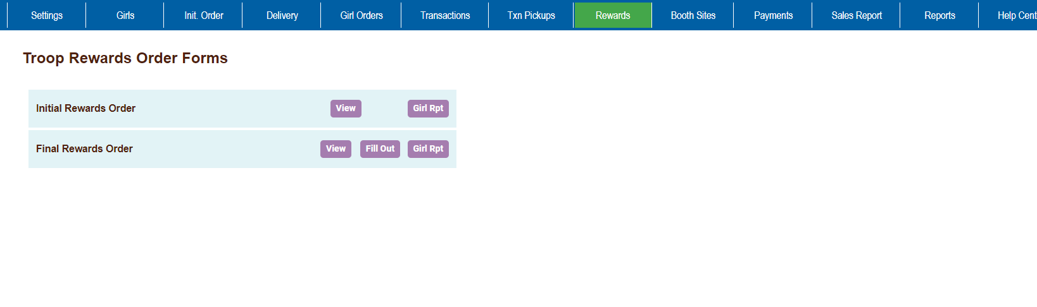
• If a reward choice is needed for any girls you will see (size/catalog selection needed) in red next to the girl’s name.
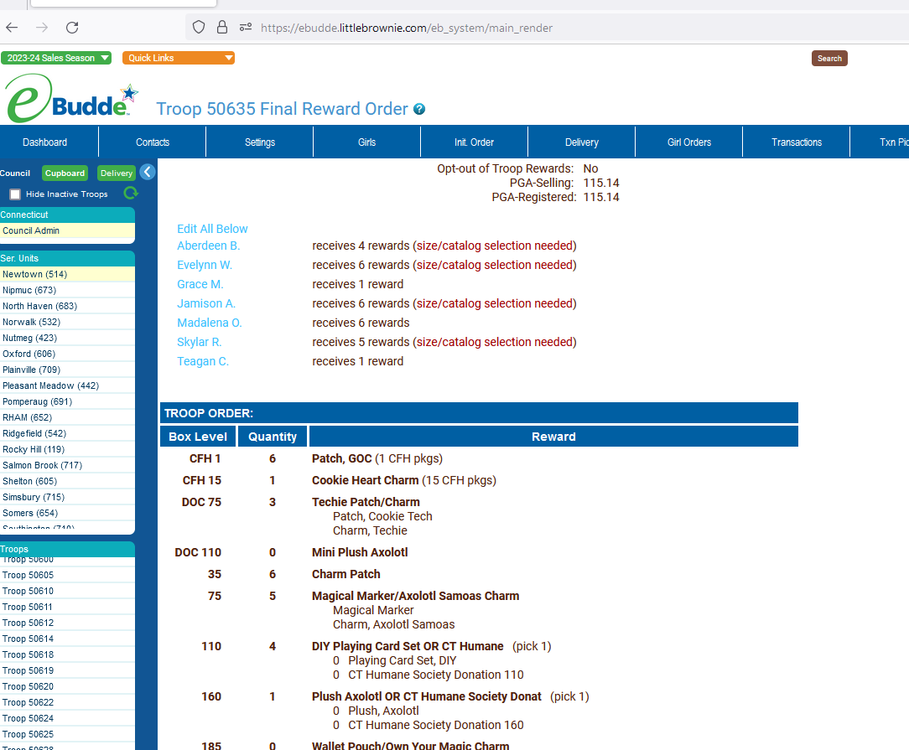
[Grab your reader’s attention with a great quote from the document or use this space to emphasize a key point. To place this text box anywhere on the page, just drag it.]

Click on the girl’s name and make the selection as needed.
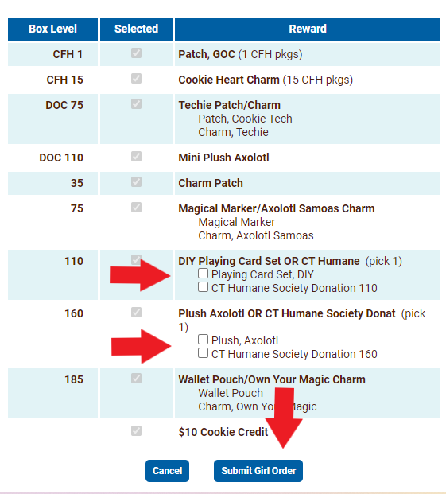
Make the selections for the girl, then scroll to the bottom of the page and click Submit Girl Order
Repeat for each girl that needs a selection made.

To finalize troop reward selections:
- After each girl is updated, scroll down to the bottom of the page and click Submit Reward Order
Once this is completed you have finalized your troop’s reward order.

Thank you for helping your troop with the Cookie Program!

